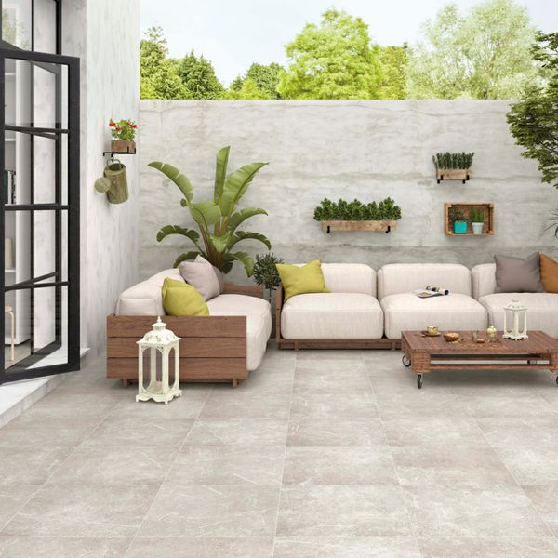

Medici Plus Natural Porcelain Paving Slabs: <https://www.wallsandfloors.co.uk/medici-plus-natural-600x600x20-tiles>

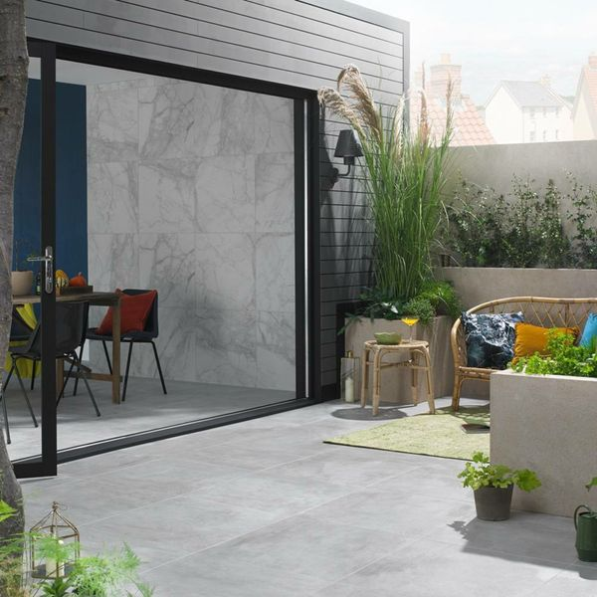

Mist Chalk Concrete Effect Porcelain Paving Slabs: <https://www.wallsandfloors.co.uk/mist-chalk-concrete-effect-porcelain-paving-slabs>

Vesuvius Charcoal Split Face Effect Tiles:

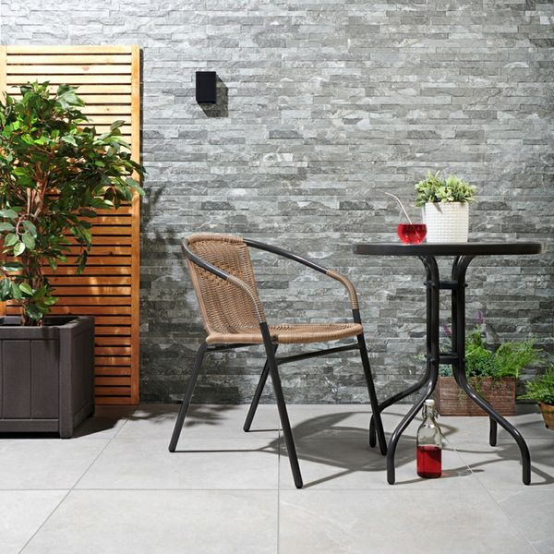

<https://www.wallsandfloors.co.uk/vesuvius-split-face-effect-tiles-charcoal-split-face-effect-tiles>

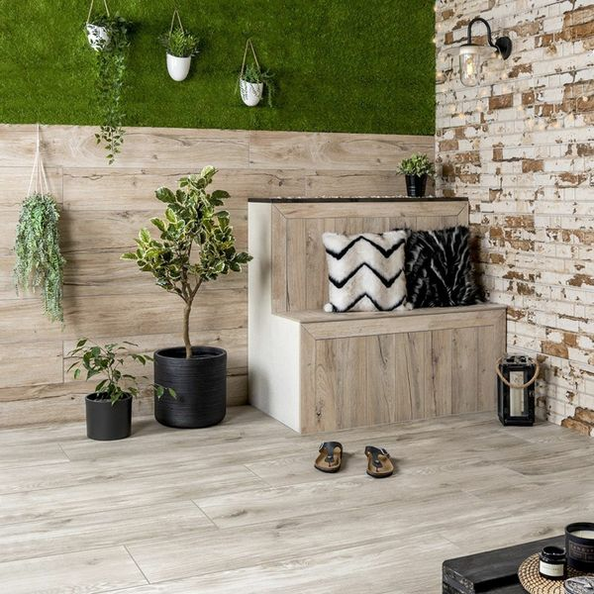

Sherwood Natural Wood Effect Porcelain Paving Slabs: <https://www.wallsandfloors.co.uk/sherwood-natural-20mm-wood-effect-tiles>

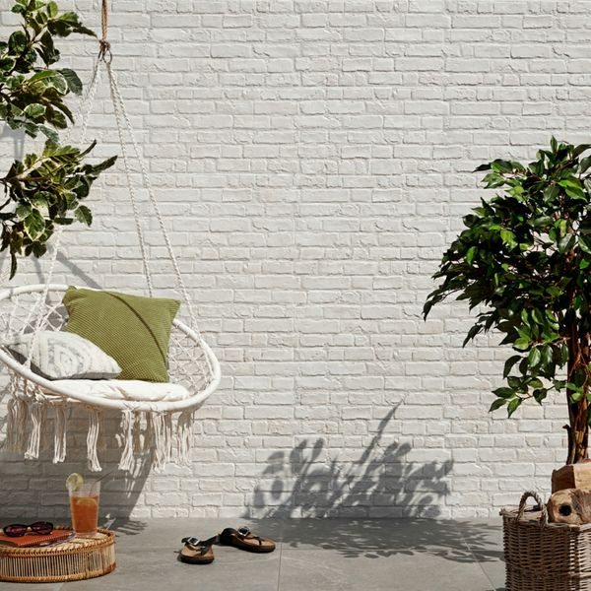

Rustic Masonry Dove White Brick Effect Tiles: <https://www.wallsandfloors.co.uk/rustic-masonry-brick-effect-tiles-dove-white-painted-brick-effect-tiles>

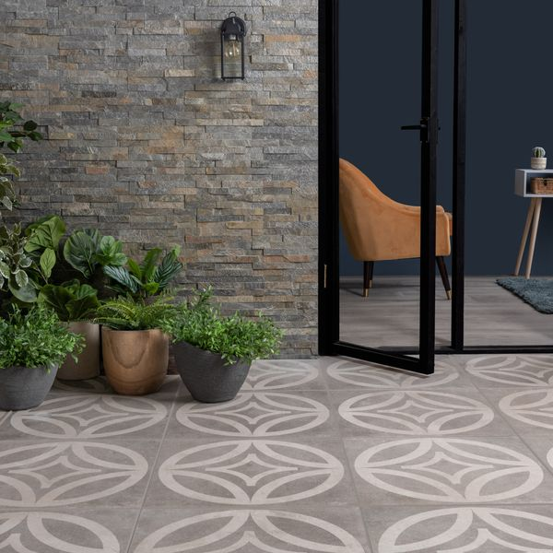

Leinz Sion Patterned Porcelain Paving Slabs: <https://www.wallsandfloors.co.uk/leinz-sion-patterened-porcelain-paving-slabs>